**Encoding and Decoding of Matrices**

**History:**

Cryptography, to most people, is concerned with keeping communications private. Indeed, the protection of sensitive communications has been the emphasis of

cryptography throughout much of its history.  Encryption is the transformation of data into some unreadable form. Its purpose is to ensure privacy by keeping the information hidden from anyone for whom it is not intended, even those who can see the encrypted data. Decryption is the reverse of encryption; it is the transformation of encrypted data back into some intelligible form.

Encryption and decryption require the use of some secret information, usually referred to as a key. Depending on the encryption mechanism used, the same key might be used for both encryption and decryption, while for other mechanisms, the keys used for encryption and decryption might be different.

Today governments use sophisticated methods of coding and decoding messages. One type of code, which is extremely difficult to break, makes use of a large matrix to encode a message. The receiver of the message decodes it using the inverse of the matrix. This first matrix is called the encoding matrix and its inverse is called the decoding matrix.

**Concept:**

 Let A be the encoding matrix, M the message matrix, and X will be the encrypted matrix. Then, mathematically, the operation is



(Note, the sizes of A and M will have to be consistent and will determine the size of X.) OK, let's say someone has X and knows A. and wants to recover M, the original message. That would be the same as solving the matrix equation for M. Multiplying both sides of the equation on the left by  we have



**Procedure:**

* Convert letters into alphabets by A=1,B=2,C=3 etc.
* Select an encoding matrix
* Multiply message matrix with encoding matrix
* Find Decoding matrix as inverse of encoding matrix
* Multiply decoding matrix with encoded matrix to get message matrix

**Handwritten Solution:**

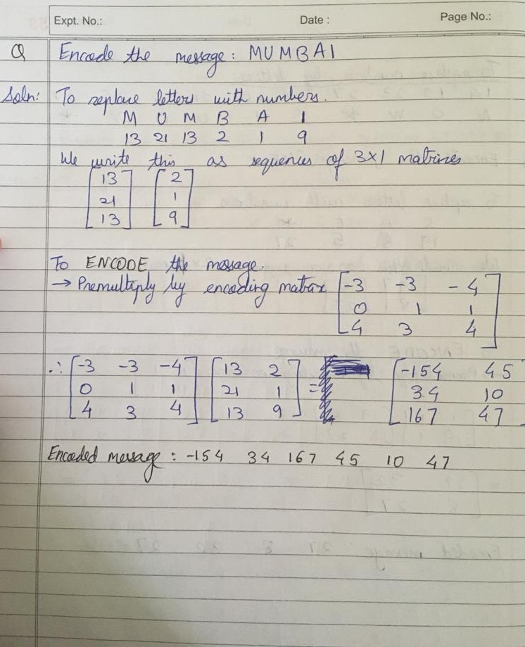

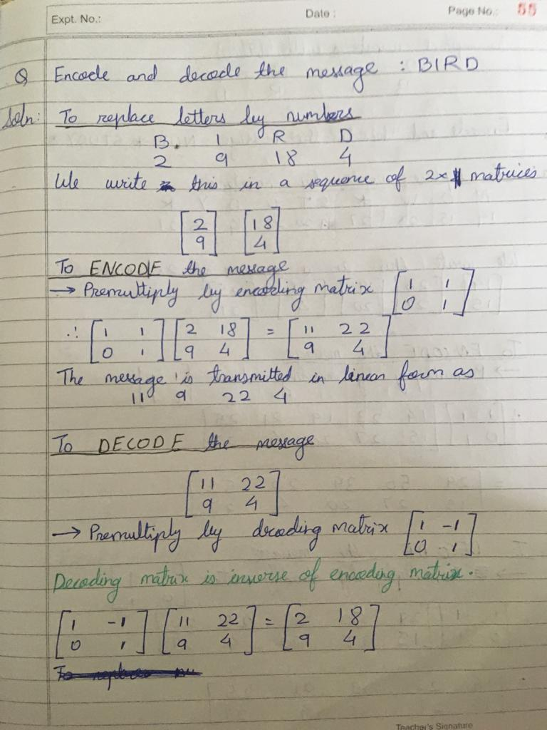

**Solved Example:**

**Encoding Example-**

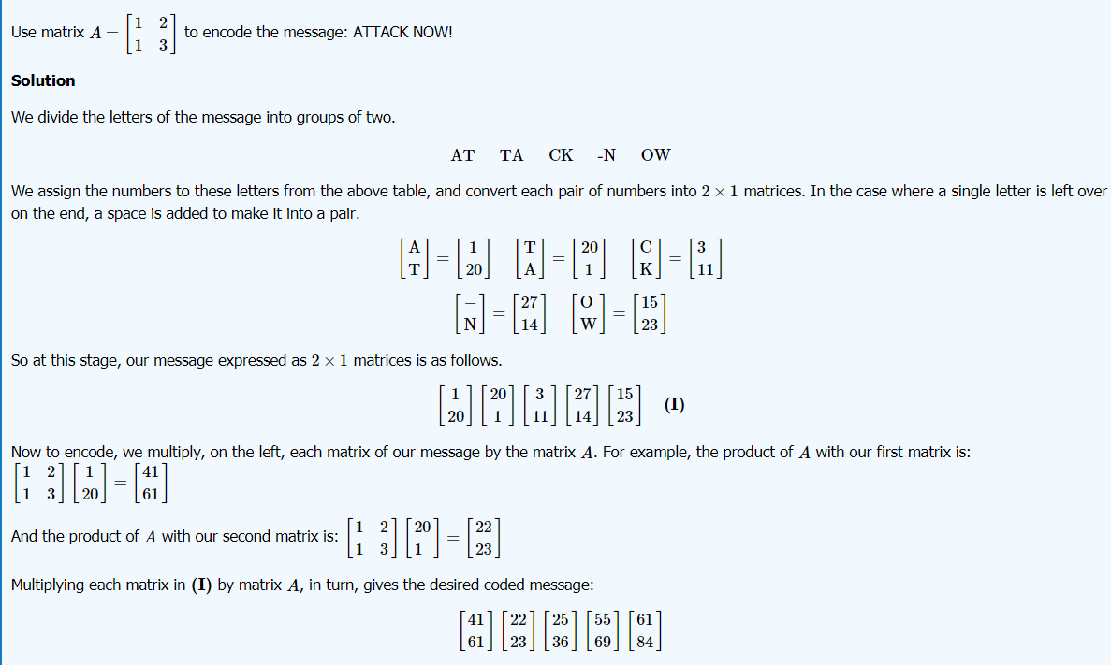

**Decoding Example-**

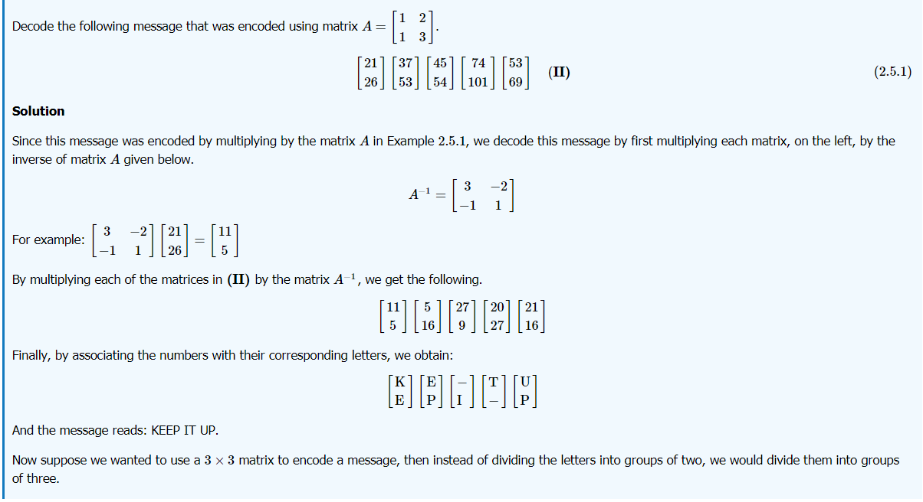

**Homework Question:**

**Q. Encode the message “THE EAGLE HAS LANDED” with the encoding matrix:**

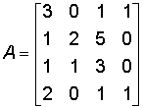

**And decode the same and verify by getting the message back.**

**Applications:**

* **Cryptography**
* **Image processing**
* **File encoding**